Academic Year: 2024-25 | Year: First Year | Term: I
Roll No.: | 11
Name: | Riddhee Sandeep Kulkarni
Subject: FCP
Assignment No.: | 30
Title: | Student records
Date:

Contents
1. Theory (Logic) 2
2. Pseudo Code 2
3. Program Code 2
4. Output 2
5. Conclusion 2

THEORY:

This code demonstrates file handling to display some student records from a file.

PSEUDO CODE:

Step 1: Start

Step 2: define variables

Step 3: define main function

Step 4: accept file name from user

Step 5: write code to display student record from a file

Step 5: print output

Step 6: end

PROGRAM CODE:

#include <stdio.h>

#include <string.h>

#include <stdlib.h>

void main()

{

FILE *fptr;

char ch;

char file[50];

printf("Enter the name of the file: ");

scanf ("%s",file);

fptr = fopen(file, "r");

if(fptr == NULL)

{

printf("File cannot be opened:");

exit (1);

}

printf( "Content of the files are: \n");

while ((ch = fgetc(fptr)) != EOF)

{

printf("%c", ch) ;

}

fclose(fptr) ;

}

OUTPUT:

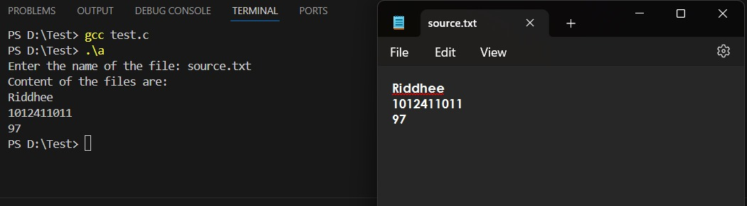

CONCULSION:

Code is run successfully, required output received

